Eric Bochsler and Daniel Stromecki

Homework 7 pt. 2: Final Project

**Characterization of Globular Clusters from the New General Catalogue**

**Summary of Questions and Results:**

1. Is there a correlation between the visual magnitude V and B-V color magnitude of globular clusters? There is no correlation between V and B-V.
2. Is there a correlation between the B-V and U-B color magnitude of globular clusters? There is a fairly strong correlation between B-V and U-B.
3. What is the average absolute visual magnitude V, color magnitude B-V, and color magnitude U-B for NGC globular clusters? V = -7.688, B-V = 1.018, U-B = 0.404
4. What is the average distance to the globular clusters and what is the average radial velocity of globular clusters? R_sun = 11.49 Kpc, v_r = -7.712 km/s
5. Is there a correlation between the distance to globular clusters and their radial velocities? There is no correlation between radial velocities and distances from Earth.
6. What is the average metallicity and weighted metallicity measurements for NGC globular clusters? [Fe/H] = -1.363, wt = 4.509

**Motivation and Background:**

Globular clusters are some of the oldest groups of stars within our galaxy. Besides being old, the stars within globular clusters were all formed at about the same time. We can use what we know about the lifecycle of stars to find the age of globular clusters. Since larger, brighter stars live shorter lives, we can find the size of stars that are beginning to turn-off from the “main sequence” of stars. This can tell us the age of the globular cluster. Since globular clusters are some of the oldest objects in the galaxy, their age gives us a good idea about the age of our galaxy and the universe. Therefore, the characterization of globular clusters within our galaxy is important to galactic and stellar astronomy.

**Dataset:**

<http://physwww.physics.mcmaster.ca/~harris/mwgc.dat>, Compiled by William E. Harris, McMaster University: A data set that includes information on various Globular Clusters within the Milky Way Galaxy. The majority of the Globular Clusters in the dataset are from the New General Catalogue and therefore have an ID beginning with NGC. This project isolates data from these Globular Clusters which are then characterized.

**Methodology:**

Data is read in from the data set using urllib2.urlopen(). Only data from NGC globular clusters are read in and stored as a list of strings where strings represent individual lines of the data file. A nested dictionary is then created where all included globular cluster IDs are keys that map to dictionaries where the data are stored under keys that correspond to their labels. Means are computed and printed for values of interest. Plots are created and saved as images. For each plot, scipy.stats.pearsonr() is used to find the correlation value and p-value for the two lists of numbers plotted against each other. This is used to conclude if the plotted values are correlated.

**Results:**

1. There was not found to be a correlation between the B-V color and absolute visual magnitude V of NGC globular clusters. The lack of correlation is apparent by simply observing the plot below. A value for correlation was found to be 0.05608 by the program. This is very close to 0 which is the value where no correlation at all is found. We therefore reject that visual magnitude V and B-V color are correlated. This is interesting because a single cluster would be expected to have correlation due to stars on the main sequence. Comparing individual clusters is therefore different.

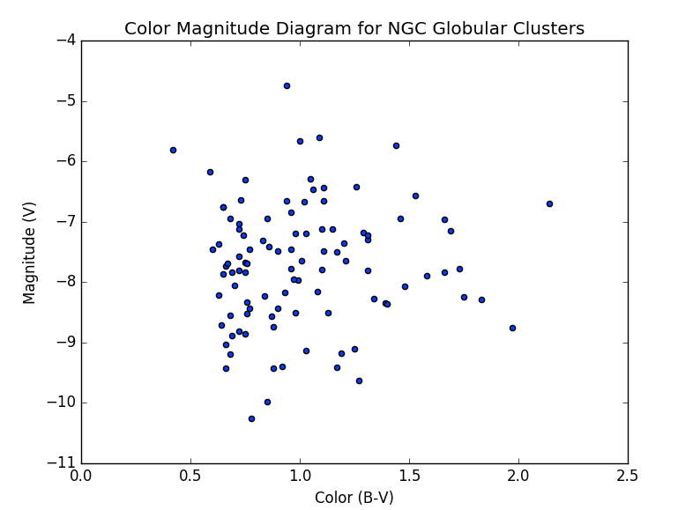

2. A fairly strong correlation was found between the U-B and B-V color magnitudes for the NGC globular clusters. The correlation is apparent simply by observing the plot below. A correlation value of 0.932844 was found between the U-B and B-V values. This is very close to 1.0 which indicates perfect positive correlation. We therefore accept that there is positive correlation between the U-B and B-V color magnitudes. This result makes sense because we expect that clusters that are younger and therefore have more blue stars will be higher in both B and U magnitudes than older clusters with more red stars. It therefore makes sense for clusters with higher U-B values to also have higher B-V values.

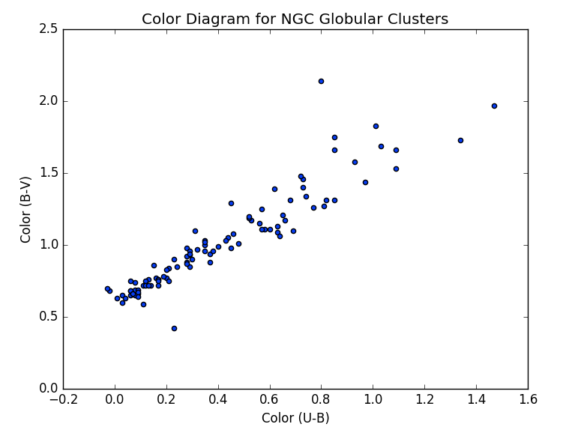

3. The program found that the mean values for absolute visual magnitude and color magnitudes of the NGC globular clusters are as follows: V = -7.688, B-V = 1.018, and U-B = 0.404. These results are not surprising. They are typical for the set of NGC globular clusters and for globular clusters in general.

4. The program found that the mean values for distance from the Sun and radial velocity of the NGC globular clusters are as follows: R_sun = 11.49 Kpc, v_r = -7.712 km/s. These results seem typical for the NGC globular cluster data and for globular clusters in general. The value for distance from the Sun (R_sun) is a bit surprising because it is such a large distance. For context, the diameter of the Milky Way is estimated to be between 30 and 50 Kpc. When we consider that globular clusters are located in the halo of the galaxy, the result no longer seems surprising. There is one globular cluster that can be seen on the plot below that is surprising. It is much further away than the other globular clusters, over 80 Kpc away.

5. We conclude that there is not a strong correlation between the distance from a globular cluster to the Sun and the radial velocity of the cluster. The plot below shows that there is not much of a linear relationship between distance from the Sun and radial velocity. Our program gave a correlation value of -0.149738 which means that a very weak negative correlation was found. Since this is much closer to 0 that corresponds to no correlation than -1.0 which corresponds to perfect negative correlation, we reject that there is correlation between distance from the Sun and radial velocity. This is not surprising because there is no reason that distance from the Sun should affect how a cluster moves with respect to the Sun.

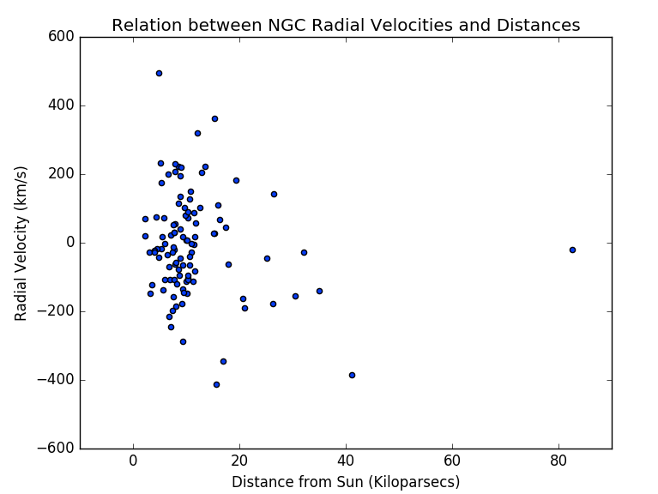

**6.**  The program found that the mean metallicity value and weight of the mean metallicity value are as follows: [Fe/H] = -1.363, wt = 4.509. The weight of 4.509 does seem surprising. Only 4.5 independent measurements to find metallicity seems very low. This could indicate a need for more measurements to get a more accurate metallicity value. The plot below demonstrates this. As can be seen, many metallicity values were determined with just 2, 3, or 4 independent measurements. Far fewer were determined with a larger number of measurements.

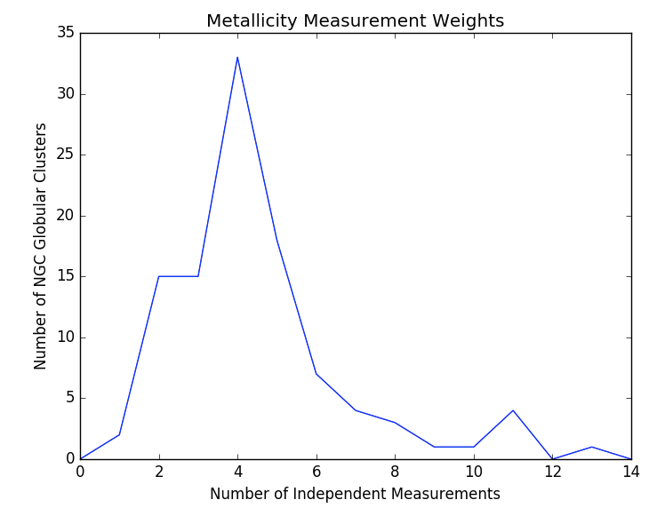

**Reproducing Results:**

Our code can simply be run by typing python globular_clusters.py into the terminal window. Everything is taken care of by the main() function of the program, so no user input is required. A key that gives information about abbreviations and units of values will be printed first. After this is printed, mean values for the NGC globular clusters is printed. Statistical information is printed last which includes correlation values and p-values. Plots will be saved as images in files colormag.png, colorcolor.png, velocity.png, and histogram.png.

**Work Plan Evaluation:**

Some estimates from part 1 were good, while others were not. It took much longer than expected to organize the data into a useful dictionary. This is because the data was in the form of a dat file and some clusters had more information than others. We probably spent more time on this than any other step. Some of the functions were easier to write than expected and therefore took less time.

**Presentation:**

We have chosen to submit a video presentation. Therefore, we have opted out of doing a live presentation.

**Collaboration:**

We did not collaborate with any other students in the class.